Getting ready for the job

git how to run test python: This is a Yaml file, to configure GitHub to run automatic Unit-Tests
https://docs.github.com/en/actions/automating-builds-and-tests/building-and-testing-python

name: Python package

on: [push]

jobs:
build:

runs-on: ubuntu-latest
strategy:
matrix:
python-version: ["3.7", "3.8", "3.9", "3.10"]

steps:
- uses: actions/checkout@v3
- name: Set up Python ${{ matrix.python-version }}
uses: actions/setup-python@v4
with:
python-version: ${{ matrix.python-version }}
- name: Install dependencies
run: |
python -m pip install --upgrade pip
pip install flake8 pytest
if [ -f requirements.txt ]; then pip install -r requirements.txt; fi
- name: Lint with flake8
run: |
# stop the build if there are Python syntax errors or undefined names
flake8 . --count --select=E9,F63,F7,F82 --show-source --statistics
# exit-zero treats all errors as warnings. The GitHub editor is 127 chars wide
flake8 . --count --exit-zero --max-complexity=10 --max-line-length=127 --statistics
- name: Test with pytest
run: |
pytest

PyEnv setup

Install 'pyenv' Python version manager on Ubuntu 20.04

Overview:
pyenv - is a simple Python version manager tool, which allows you easily switch between multiple versions of Python. You can set local or global system-wide Python versions via the tool.

Installation:
- Install all required prerequisite dependencies:
sudo apt-get update; sudo apt-get install make build-essential libssl-dev zlib1g-dev \
libbz2-dev libreadline-dev libsqlite3-dev wget curl llvm \
libncursesw5-dev xz-utils tk-dev libxml2-dev libxmlsec1-dev libffi-dev liblzma-dev
Download and execute installation script:
curl https://pyenv.run | bash
- Add the following entries into your ~/.bashrc file:
# pyenv
export PATH="$HOME/.pyenv/bin:$PATH"
eval "$(pyenv init --path)"
eval "$(pyenv virtualenv-init -)"
- Restart your shell:
exec $SHELL
- Validate installation:
pyenv --version

How to use in your workspace:
- Create a local “default” python version by creating a .python-version file. Inside of it you just need to specify the version [e.g: 3.7.12] (That’s it!)
- Ensure that the needed version exists:
  - $ pyenv install –skip-existing $(cat .python-version)
- Validate that pyenv and the needed version are working properly with:
  - $ pyenv version (you expect to see the version to specified in .python-version)
  - $ python -V (you expect to see the version to specified in .python-version)
- Create a Virtual Env for python:
  - $ python -m venv .venv
- Basic setup commands:
  - $ source .venv/bin/activate
  - $ pip install -U pip setuptools
  - $ pip install -r requirements.txt

Workspace settings

https://code.visualstudio.com/docs/getstarted/settings#_workspace-settings

Workspace settings are specific to a project and can be shared across developers on a project. Workspace settings override user settings.
Note: a VS-Code "workspace" is usually just your project root folder. Workspace settings as well as debugging and task configurations are stored at the root in a .vscode folder.

Ctrl+Shift+P >>> Preferences: Open Workspace Settings
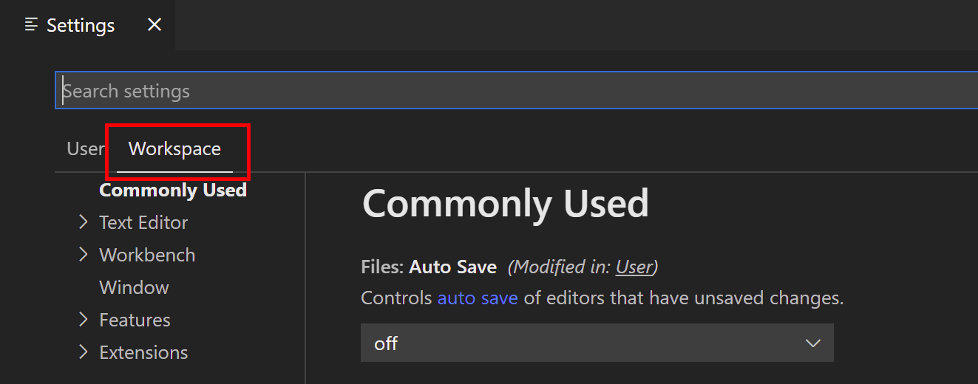

Ctrl+Shift+P >>> Preferences: Open Workspace Settings(JSON)
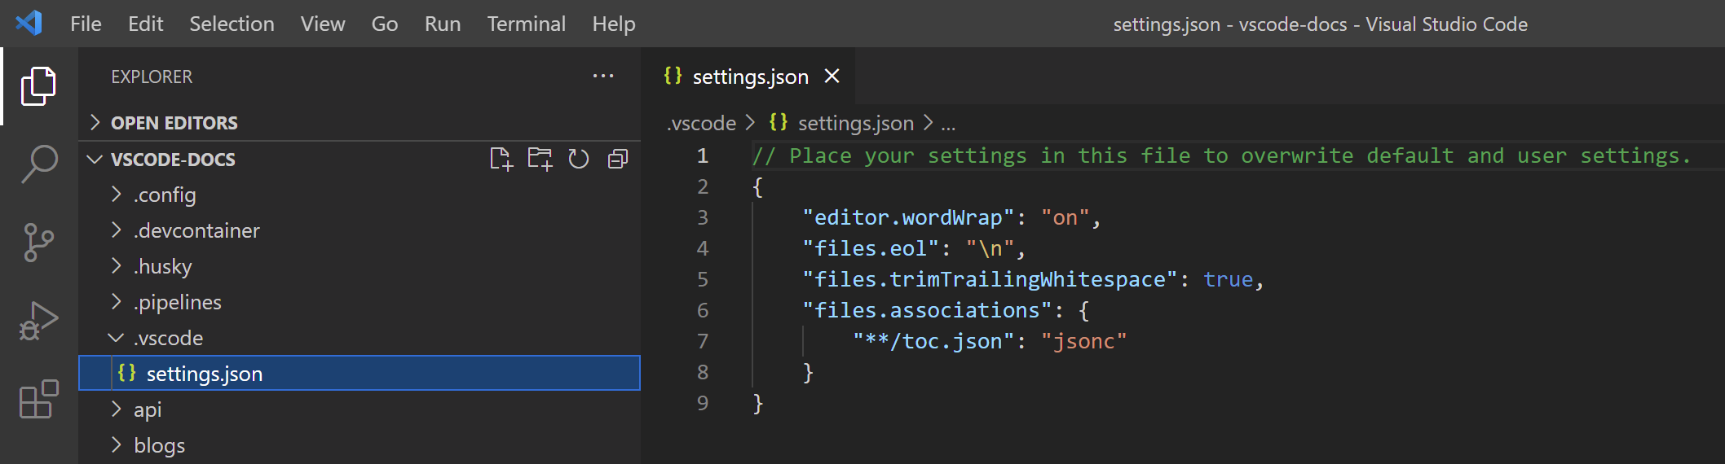
The workspace settings file is located under the .vscode folder in your root folder, this is a file named settings.json

How to enable Python type checking in VSCode

https://www.emmanuelgautier.com/blog/enable-vscode-python-type-checking
Using Internal Pylance
Since version 3.5, Python now has support for type hints. This typing is a cool new feature allowing type checking across your code for more quality and also help when you are using some packages or call some functions your colleague did in a large codebase. In this article, we will see how to enable type IntelliSense and type checking analysis in Visual Studio Code editor.
First of all, you need to install the Microsoft extension Pylance. This extension provides a set of useful features powered with Pyright, the Microsoft static type checking tool.
With the extension installed and enabled, you should now have better IntelliSense with typing information when you are calling some package function for example. For the type checking analysis, it is not enabled by default, you need to configure it by yourself.
In your .vscode/settings.json file, add a new line with the following setting:
{
"python.analysis.typeCheckingMode": "basic"
}

https://dev.to/jodaut/python-type-checking-with-visual-studio-code-46a7
Using external Mypy + Gitlens

Install Mypy
Next, install Mypy. This package checks types in your Python code and define a set of rules according to your needs.

Setup
pip install mypy

Add Gitlens extension
Install GitLens extension for VS Code.
Next, add these settings in your local settings.json.
{
"python.linting.mypyEnabled": true,
"python.linting.mypyArgs": [
"--ignore-missing-imports",
"--follow-imports=silent",
"--show-column-numbers",
"--allow-untyped-defs",
"--allow-subclassing-any",
"--allow-untyped-calls",
"--strict"
]
}
AutoDocstring (Extention)

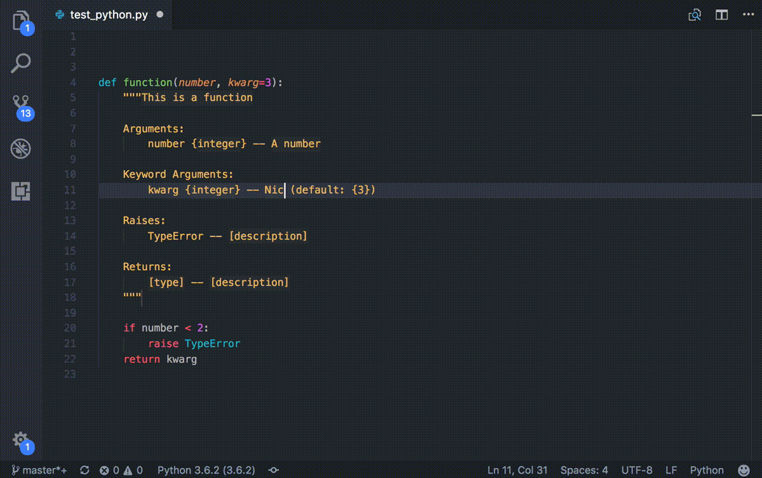
Cursor must be on the line directly below the definition to generate full auto-populated docstring

Press enter after opening docstring with triple quotes (configurable """ or ''')
Keyboard shortcut: ctrl+shift+2 or cmd+shift+2 for mac
Can be changed in Preferences -> Keyboard Shortcuts -> extension.generateDocstring
Command: Generate Docstring
Right click menu: Generate Docstring
Extension Settings
This extension contributes the following settings:

autoDocstring.docstringFormat: Switch between different docstring formats
autoDocstring.customTemplatePath: Path to a custom docstring template (absolute or relative to the project root)
autoDocstring.generateDocstringOnEnter: Generate the docstring on pressing enter after opening docstring
autoDocstring.includeExtendedSummary: Include extended summary section in docstring
autoDocstring.includeName: Include function name at the start of docstring
autoDocstring.startOnNewLine: New line before summary placeholder
autoDocstring.guessTypes: Infer types from type hints, default values and variable names
autoDocstring.quoteStyle: The style of quotes for docstrings

Black Formatter for VS-Code

https://dev.to/adamlombard/how-to-use-the-black-python-code-formatter-in-vscode-3lo0
Black is "the uncompromising Python code formatter." It can be configured to automatically format your code whenever you save a file in VSCode.
Install Black in your virtual environment:
$ pip install black
Install Microsoft's Python extension in VSCode:
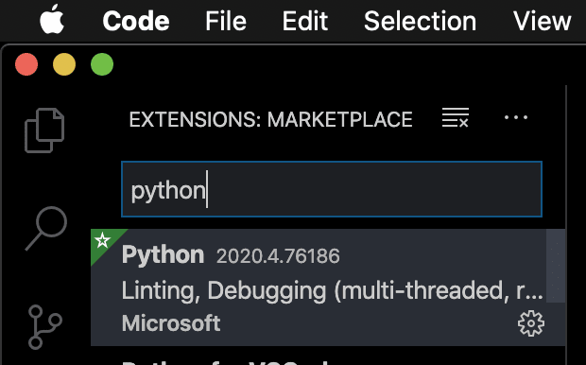
Open your VSCode settings, by going 'Code -> Preferences -> Settings'.
Search for "python formatting provider" and select "black" from the dropdown menu:
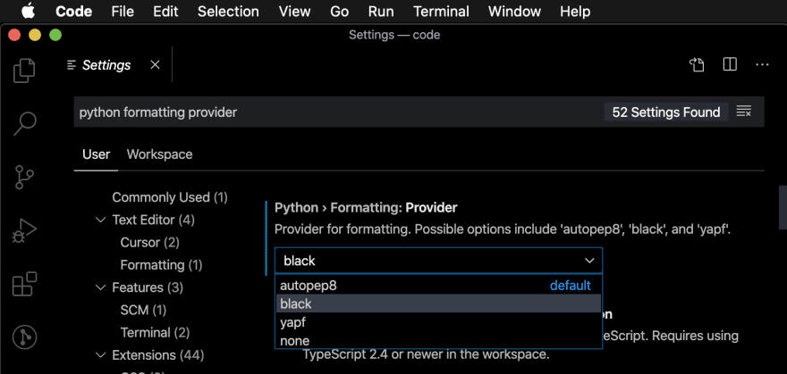
In the settings, search for "format on save" and enable the "Editor: Format on Save" option:
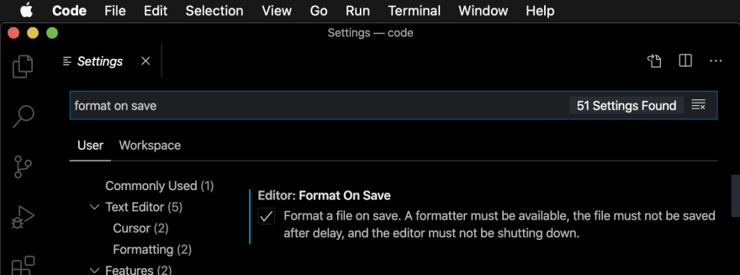
Black will now format your code whenever you save a *.py file.
Before saving:
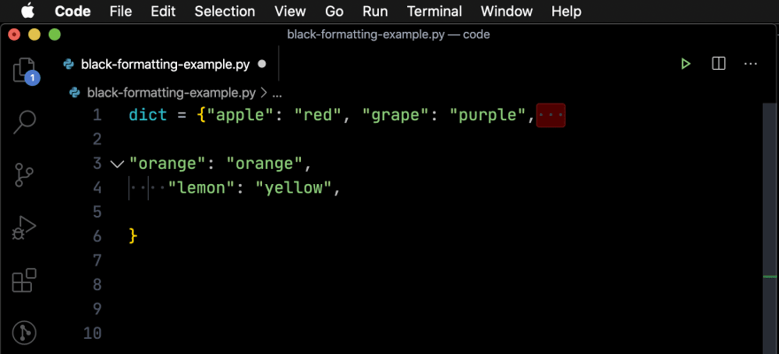
After saving:
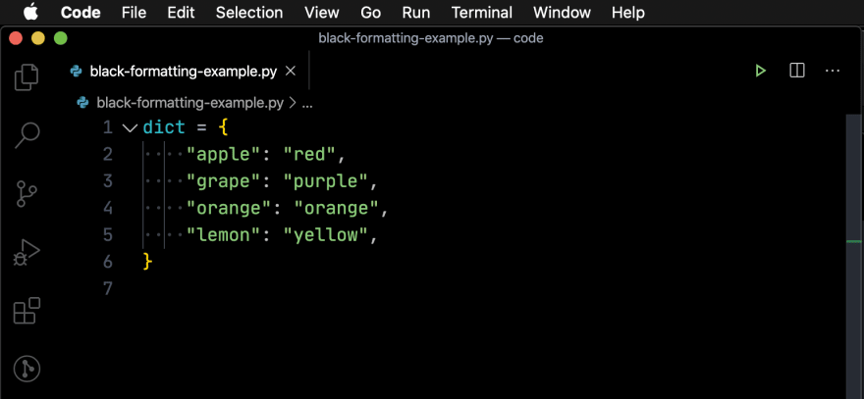

More: How to set Black line lengths in VSCode

From https://marketplace.visualstudio.com/items?itemName=ms-python.black-formatter
You can push Ctrl+p and put ext install ms-python.black-formatter this will install the extention automatically
Here are my settings: (From StackOverflow) [Only this method worked for me]
// User Settings <--- First configure the Local User’s settings

"editor.defaultFormatter": null,
"editor.formatOnSave": false, // enable per language
"[python]": {
"editor.formatOnSave": true
},
"python.formatting.provider": "black",
"python.formatting.blackPath": "/usr/local/bin/black"

// Workspace Settings <--- Finish with setting the team’s black version

"python.formatting.blackPath": "/absolute/path/to/venv/with/black",
"python.formatting.blackArgs": [
"-l 120"
],

Isort – Sorts the imports to pep8 standard

$ pip install black isort

{
"[python]": {
"editor.tabSize": 4,
// requires "ms-python.black-formatter"
// not able to install not-released "dev" extension into devcontainer
// "editor.defaultFormatter": "ms-python.black-formatter",
"editor.formatOnSave": true,
"editor.codeActionsOnSave": {
"source.organizeImports": true
}
},
"python.formatting.blackPath": "/home/misha/projects/test_black/test_black_venv/bin/black",
"python.formatting.blackArgs": [
"-l 120"
],
"python.linting.enabled": true,
"isort.path": [
"/home/misha/projects/test_black/test_black_venv/bin/isort"
],
"isort.args": [
"--profile",
"black",
"--line-length",
"99",
"--skip-gitignore",
"--settings-file",
"./.isort.cfg",
],
}

[project’s .isort.cfg file]
[settings]
profile=black
line_length=99
skip_gitignore=true

Full setting of Isort, black, ...

https://github.com/microsoft/vscode-isort/issues/53

"python.languageServer": "Pylance",
"python.formatting.provider": "black",
"python.linting.pylintArgs": [
"--disable=missing-docstring,unused-import",
"--max-line-length=99"
],
"python.linting.flake8Args": [
"--max-line-length=99",
"--ignore=E402,F841,F401"
],
"python.linting.pylintPath": "/home/vscode/.local/bin/pylint",
"[python]": {
"editor.tabSize": 4,
"editor.defaultFormatter": "ms-python.black-formatter",
"editor.formatOnSave": true,
"editor.codeActionsOnSave": {
"source.organizeImports": true
}
},
"black-formatter.args" : [
"--line-length",
"99"
],
// "isort.path": ["/usr/local/bin/isort"],
"isort.args": [
"--profile",
"black",
"--line-length",
"99",
"--skip-gitignore",
"--settings-file",
"./.isort.cfg",
],

Example from: https://github.com/keras-team/keras/blob/master/.vscode/settings.json
"python.linting.flake8Enabled": true,
"python.linting.enabled": true,
"editor.rulers": [80],
"editor.formatOnSave": true,
"python.formatting.provider": "black",
"python.formatting.blackArgs": [
"--line-length",
"80"
],
"python.sortImports.args": [
"--profile",
"black",
"--sl"
],
"[python]": {
"editor.codeActionsOnSave": {
"source.organizeImports": true
}
},
"python.analysis.diagnosticSeverityOverrides": {
"reportMissingImports": "none"
}

Visual Code – Useful shrotcuts

Ctrl + J === Hide bottom panel
Ctrl + , === Settings User/Workspace
Alt + <Up/Down Key> === Switch rows up/down

code . (in terminal) === Opens VS-Code opened in that folder

